
CENTRAL WEST EDUCATION DIVISION
2026 MALAWI SCHOOL CERTIFICATE OF EDUCATION
MOCK EXAMINATION
BIOLOGY
PAPER I
100 MARKS
Wednesday, 18 March Subject Number: M022/I
Time allowed: 2hours
08:00 am – 10:00 am

Instructions
- This paper contains 11 printed pages. Please check.
- Write your candidate number on top of each and every page,
- This paper has two sections, A and B. Section A has ten questions and section B has three questions.
- Answer all the 13 questions in the spaces provided. The maximum number of marks for each question is indicated against it.
- In the table provided on this page, tick against the question number you have answered.
- At the end of the examination, hand in your paper to the invigilator when time is called to stop writing.

Question number | Tick if answered | Do not write in these columns
1
2
3
4
5
6
7
8
9
10
11
13
13
Total

SECTION A (70 MARKS)
- Figure 1 shows the human digestive system. Use it to answer the questions that follow

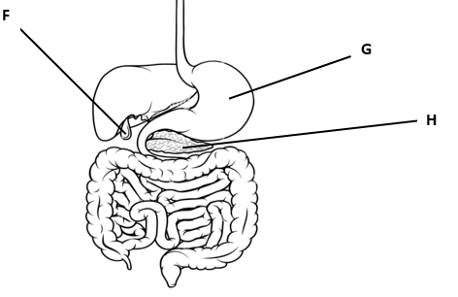
Figure 1
- Name the part labelled H
_______________________________________________________________________ (1 mark)
- Name the fluid secreted by part labelled F
________________________________________________________________________ (1 mark)
- Mention two functions of the fluid named in b above
- _____________________________________________________________________ (1 mark)
- _____________________________________________________________________ (1 mark)
- Mention two ways in which part labelled G is protected from auto digestion
- _____________________________________________________________________ (1 mark)
- _____________________________________________________________________ ( 1 mark)
- State any two principles of Mendelian genetics
- _____________________________________________________________________ ( 1 mark)
- _____________________________________________________________________ ( 1 mark)
b. A normal male married a haemophilia carrier female. Use H for normal blood clotting allele and h for haemophiliac allele.
- Show the inheritance of haemophilia using the punnet square

(5 marks)
- Write down the phenotypic ratio of the offspring.
_________________________________________________________________________ (1 mark)
- Mention any two other effects of mutation apart from hemophilia
- ____________________________________________________________________ (1 mark)
- ____________________________________________________________________ (1 mark)
- An ecologist was investigating the effect of soil acidity on length of internodes using maize plants. The table below shows data collected from the experiment. Use it to answer the questions that follow

Length of internodes | Frequency
2 – 4 | 6
5 – 7 | 3
8 - 10 | 9

- i. Name the type of variation shown by the results of the investigation
________________________________________________________________________ (1 mark)
ii. Mention one cause of such variation in the maize plants
_______________________________________________________________________ (1 marks)
- Draw a histogram to represent the information in the table below

(4 marks)
- Figure 2 is a diagram showing one of the nutrient cycles in the ecosystem. Use it to answer the questions that follow
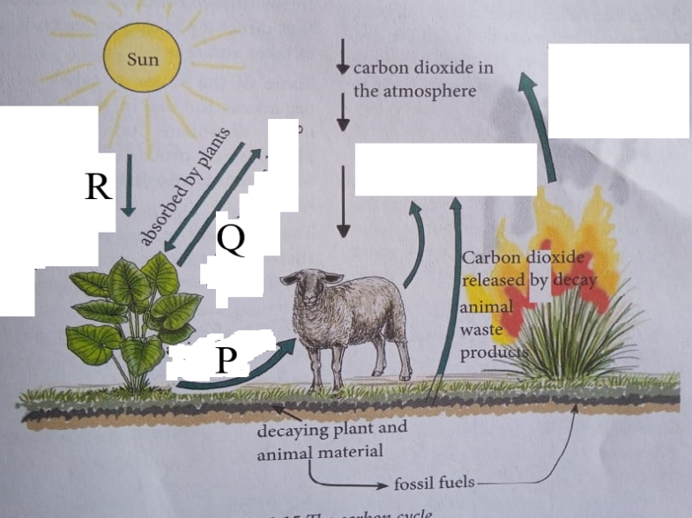
Figure 2
- Identify the processes P and R
P ______________________________________________________________________ (1 mark)
R ______________________________________________________________________ (1 mark)
- Explain any two ways in which the process represented by R is important
- ________________________________________________________________________________________________________________________ _____________________(2 marks)
- __________________________________________________________________________________________________________________________________________ (2 marks)
- a. Mention any two ways in which biotechnology is applied to solve day - to - day problems
- _____________________________________________________________________ (1 mark)
- _____________________________________________________________________ (1 mark)
- Describe one way in which genetic engineering is used to produce pest resistant crops
__________________________________________________________________________________________________________________________________________________________________________________________________________________________________________ (3 marks)
- State the reason for mostly using bacteria in genetic engineering
__________________________________________________________________________________________________________________________________________________________ (1 mark)
- Figure 3 shows the response of a bean seedling to a stimulus. Use it to answer the questions that follow.
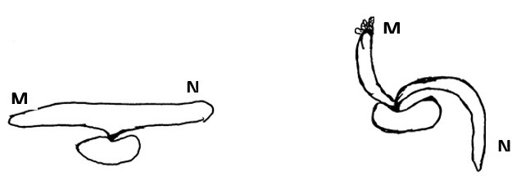

- i. Name the response shown by the seedling
_____________________________________________________________ ___________ 1 mark)
ii. State the stimulus to which the seedling responded
___________________________________________________________ __________ (1 mark)
- Describe the effect of auxin concentration on N
_______________________________________________________________________________________________________________________________________________________________________________________________________ ___________________________________ (3 marks)
- Mention any two ways of mitigating the effect of climate change.
- __________________________________________________________________________________________________________________ ______________________(1 mark)
- ________________________________________________________________________________________________________________________________________ (1 mark)
- a. State any two types of cancer
- _____________________________________________________ _________ _(1 mark)
- _____________________________________________________ __________(1 mark)
- Describe any two factors that increase the risk of cancer
- __________________________________________________________________________________________________________________ _____________________(2 marks)
- ________________________________________________________________________________________________________________________________________(2 marks)
- Mention any two effects of cancerous cells in the body
- ________________________________________________________________________________________________________________________________________ (1 mark)
- ________________________________________________________________________________________________________________________________________ (1 mark)

- Mention any two adaptations of a bird’s skeleton to flight
- _____________________________________________________________________________________________________________________ _____________________(2 marks)
- _____________________________________________________________________________________________________________________ _____________________(2 marks)
- a. State any two mechanisms that help in water movement in the xylem vessels
- __________________________________________________________________________________________________________________________ ______________________ (1 mark)
- __________________________________________________________________________________________________________________________ ______________________ (1 mark)
- Explain any two adaptations of xylem vessels to their functions
- __________________________________________________________________________________________________________________________________________ (2 marks)
- ___________________________________________________________________________________________________________________________________________(2 marks)
- Form three students found the following organisms in their woodlot; shrubs, rabbits, snakes, and an
eagle.
- Construct a food chain using the organisms found in the woodlot

(3 marks)
- i. If all the snakes were killed, what would be the impact on the population of rabbits?
__________________________________________________________________________________________________________________________________________________________ (1 mark)
ii. Explain your answer to 9b (i) above
__________________________________________________________________________________________________________________________________________________________ (1 mark)
- Give the trophic level to which an eagle belongs in the food chain
_________________________________________________________________________ (1 mark)
- a. Define the term “speciation”
_______________________________________________________________________________________________________________________________________________________________ (1 mark)
b. Mention any two ways in which speciation occurs in organisms
i._________________________________________________________________________________________________________________________________________________________ (1 mark)
ii.________________________________________________________________________________________________________________________________________________________ (1 mark)
- State any two sources of variations that contribute to natural selection
- ______________________________________________________________________ (1 mark)
- ______________________________________________________________________ (1 mark)

SECTION B (30 marks)
- Describe any five adaptations of fresh water plants to their habitat
_________________________________________________________________________________________________________________________________________________________________________________________________________________________________________________________________________________________________________________________________________________________________________________________________________________________________________________________________________________________________________________________________________________________________________________________________________________________________________________________________________________________________________________________________________________________________________________________________________________________________________________________________________________________________________________________________________________________________________________________________________________________________________________________________________________________________________________________________________________________________________________________________________________________________________________________________________________________________________________________________________________________________________________________________________________________________________________________________________________________________________________________________________________________________________________________________________________________________________________________________________________________________________________________________________________________________________________________________________________________________________________________________________________________________________________________________________________________________________________________________________________________________________________________________________________________________________________________________________________________________________________________________________________________________________________________________________________________________________________________________________________________________________________________________________________________________________________________________________________________________________________________ (10 marks)

- Explain any five adaptations of kidney tubules to their functions
__________________________________________________________________________________________________________________________________________________________________________________________________________________________________________________________________________________________________________________________________________________________________________________________________________________________________________________________________________________________________________________________________________________________________________________________________________________________________________________________________________________________________________________________________________________________________________________________________________________________________________________________________________________________________________________________________________________________________________________________________________________________________________________________________________________________________________________________________________________________________________________________________________________________________________________________________________________________________________________________________________________________________________________________________________________________________________________________________________________________________________________________________________________________________________________________________________________________________________________________________________________________________________________________________________________________________________________________________________________________________________________________________________________________________________________________________________________________________________________________________________________________________________________________________________________________________________________________________________________________________________________________________________________________________________________________________________________________________________________________________________________________________________________________________________________________________________________________________________________________________________________________________________________________________________________________________________________________________________________________________________________________________ (10 marks)

- Describe the reflex action that occurs when a person touches a sharp object.
______________________________________________________________________________________________________________________________________________________________________________________________________________________________________________________________________________________________________________________________________________________________________________________________________________________________________________________________________________________________________________________________________________________________________________________________________________________________________________________________________________________________________________________________________________________________________________________________________________________________________________________________________________________________________________________________________________________________________________________________________________________________________________________________________________________________________________________________________________________________________________________________________________________________________________________________________________________________________________________________________________________________________________________________________________________________________________________________________________________________________________________________________________________________________________________________________________________________________________________________________________________________________________________________________________________________________________________________________________________________________________________________________________________________________________________________________________________________________________________________________________________________________________________________________________________________________________________________________________________________________________________________________________________________________________________________ (10 marks)
END OF QUESTION PAPER

